

CSE461 Lab Report 01

Fall 23

**Group: 01**

**Title**

Introduction to the Raspberry Pi GPIO pins, and using push buttons to control LEDs.

***Prepared by,***

**Name:** Niloy Ahsan

**ID:** 21101255

**Section:** 09

**Introduction:**

In this Lab, we will get a foundational understanding of Raspberry Pi GPIO pins and their practical applications. The GPIO pins on the Raspberry Pi can be used for various functions. The lab aims to provide hands-on experience in using push buttons to control LEDs and knowing the practical use of GPIO pins.

**Circuit Diagram:**

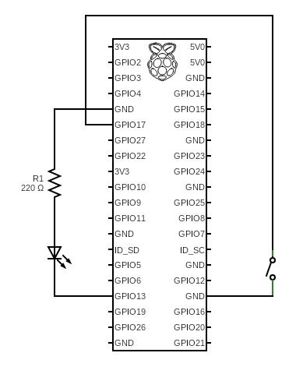

**Results:**

After connecting all the components, we powered on the device and entered the code. Next, when we push and hold the switch the LED turns ON and it remains ON as long as the switch is depressed. When the switch is released, the LED turns OFF. When it is pressed again, the LED turns on again.

**Discussion:**

After finishing this project, we were able to learn about the basic uses for the GPIO pins and how to configure and use them on the Raspberry Pi with the help of Thonny software and the Python programming language. One of the issues was that the Raspberry Pi itself was not getting the actual power and it was showing a Low Power Warning. Also, the pins were difficult to understand because of their small size.

**Question Answer:**

**1) Why is there a 220Ohms resistor in series with the LED?**

* LEDs are so sensitive. They can be damaged because of overheating. To prevent damage to the LED, a 220Ohms resistor is used in series with the LED. This resistor will limit the current flow and protect the LED from overheating.

**2) Why is the push button connected from a GPIO pin on the RPI to the GND pin of the RPI instead of being connected directly to the LED and the resistor combination?**

* To control the LED in an effective way, the push button is connected from a GPIO pin on the RPI to the GND pin of the RPI. If the push button was directly connected to the resistor and LED, the LED would always turned on, regardless of the button's condition. The circuit becomes completed when we press the button and enable us to pass the current through the LED. We can control the LED because of this configuration which makes sure that it only turns on when the button is pressed.

**3) What would happen if the series 220Ohms resistor was replaced with a 1KOhms resistor? What visual change would you see?**

* If the 220Ohm resistor in series with the LED was replaced with a 1KOhm resistor, the LED would appear dimmer compared to when the 220Ohm resistor was used. Because a 1KOhm resistor will limit the current flow more and will cause the light to be less bright. The visual change would be a reduction in the LED's brightness due to the higher resistance limiting the current flowing through the LED.

**Conclusion:**

To wrap it up, this lab provided valuable hands-on experience in working with Raspberry Pi GPIO pins and their practical applications. We successfully illustrated the basic idea of input and output interactions using a physical circuit by showing how GPIO pins can be used to activate LEDs using push buttons. All in all, this lab was a valuable learning experience that gave us the fundamental understanding required to fully utilize the Raspberry Pi's GPIO pins.